**LEFT OVER FOOD TO POOR**

### **Salesforce Developer Account Creation:**

1)After signing up you will receive an email for activation of account

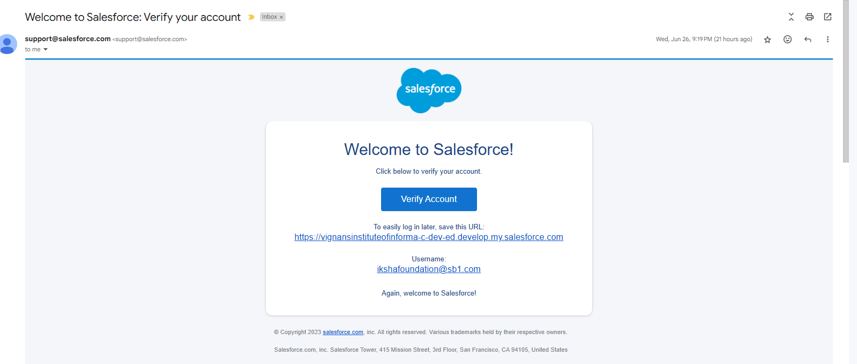

1. **Click On Verify Account**
2. **Give a password and answer a security question and click on change password**
3. **Then you will be redirected to Salesforce Setup**

### **Custom Object Creation:**

1. **Creation Of Custom objects:**

**Creating Venue object:**

1. From the setup page >> Click on Object Manager >> Click on Create >>Click on Custom Object.
2. Plural label name >> Venues
3. Click on Allow reports and Track Field History,Allow Activities.

Data Type >> Text

1. Click on Allow reports and Track Field History,Allow Activities.
2. Allow Search
3. Click on save

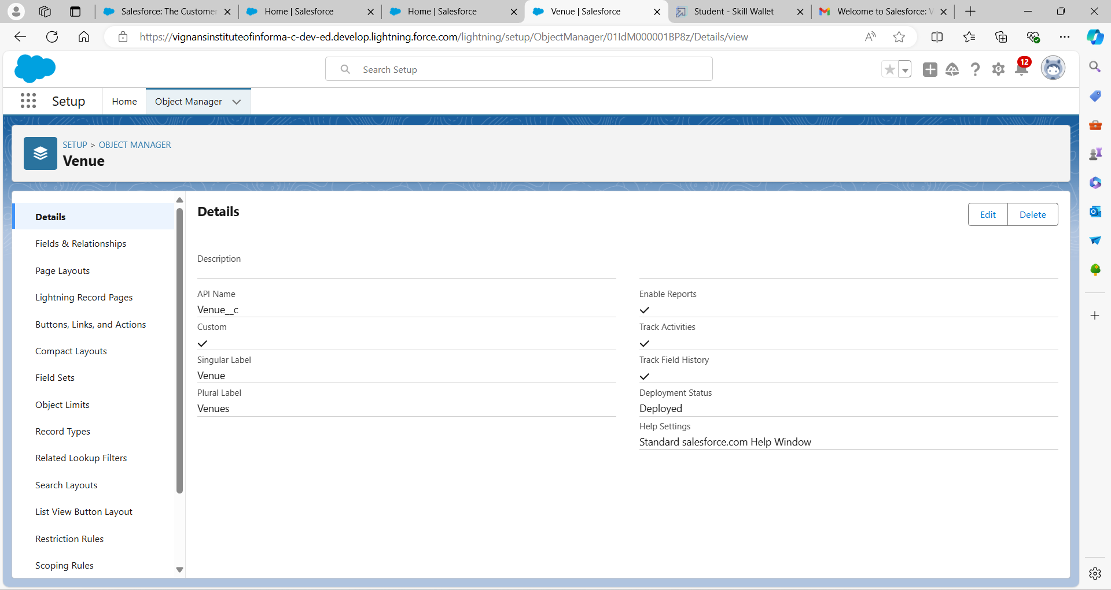

### **Create Drop-Off Point Object**

1From the setup page >> Click on Object Manager >> Click on Create >>Click on Custom Object.

2Plural label name >> Drop Off Points

3Click on Allow reports and Track Field History,Allow Activities.

Data Type >> Text

4)Click on Allow reports and Track Field History,Allow Activities.

5)Allow Search

6)Click on save

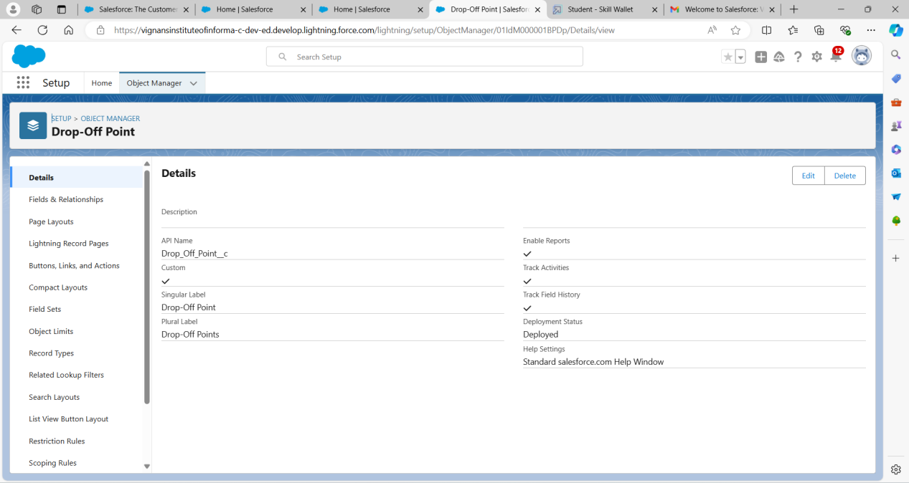

### **Create Task Object**

1From the setup page >> Click on Object Manager >> Click on Create >>Click on Custom Object.

2Plural label name >> Tasks

3Click on Allow reports and Track Field History,Allow Activities.

Data Type >> Text

4)Click on Allow reports and Track Field History,Allow Activities.

5)Allow Search

6)Click on save

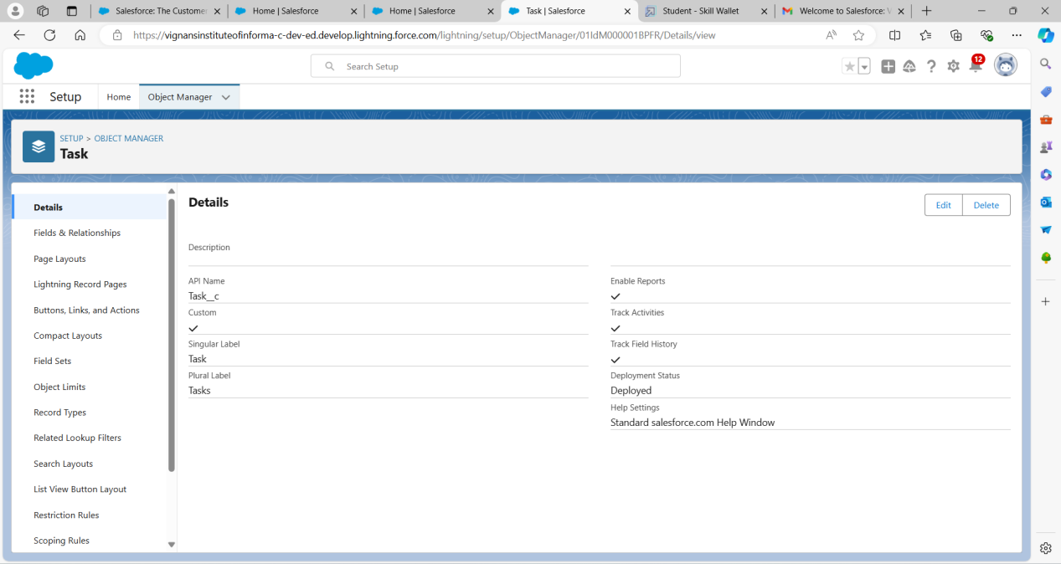

### **Create Volunteer Object**

1From the setup page >> Click on Object Manager >> Click on Create >>Click on Custom Object.

2Plural label name >> Volunteers

3Click on Allow reports and Track Field History,Allow Activities.

Data Type >> Text

4)Click on Allow reports and Track Field History,Allow Activities.

5)Allow Search

6)Click on save

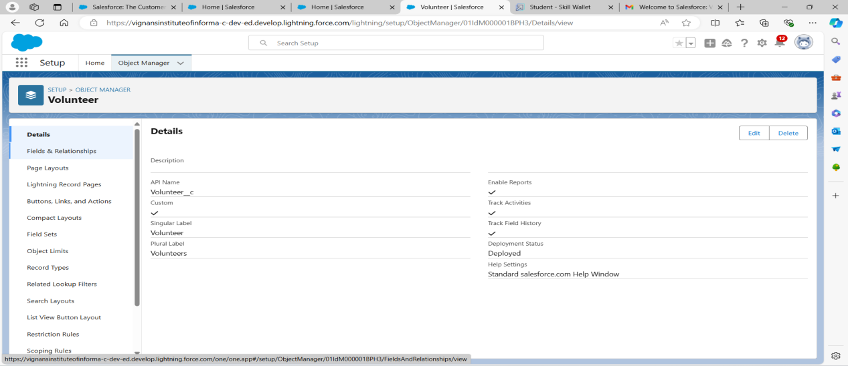

### **Create Execution Details Object**

1From the setup page >> Click on Object Manager >> Click on Create >>Click on Custom Object.

2Plural label name >> Execution Details

3Click on Allow reports and Track Field History,Allow Activities.

Data Type >> Text

4)Click on Allow reports and Track Field History,Allow Activities.

5)Allow Search

6)Click on save.

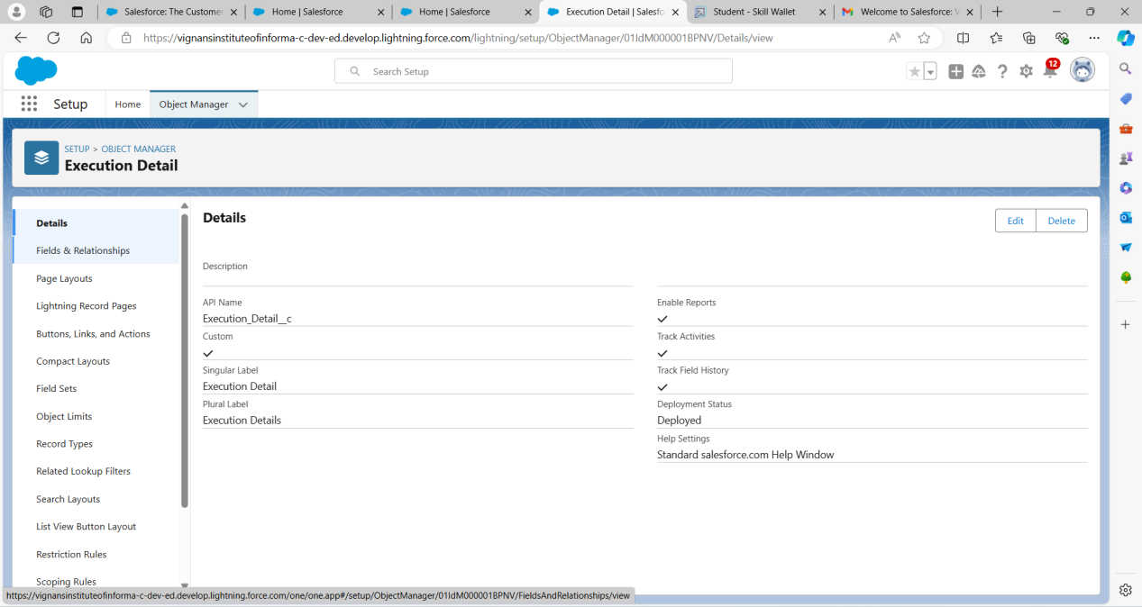

### **Tabs**

Tab is like a user interface that is used to build records for objects and to view the records in the objects

**Creating a custom Tabs Venues,Dropoff Points,Volunteers,Tasks,Execution Details:**

1. Go to setup page >> type Tabs in Quick Find bar >> click on tabs >> New (under custom object tab)
2. Select Object(Venue) >> Select the tab style >> Next (Add to profiles page) keep it as default >> Next (Add to Custom App)  uncheck the include tab .
3. Make sure that the Append tab to users' existing personal customizations is checked.
4. Save.

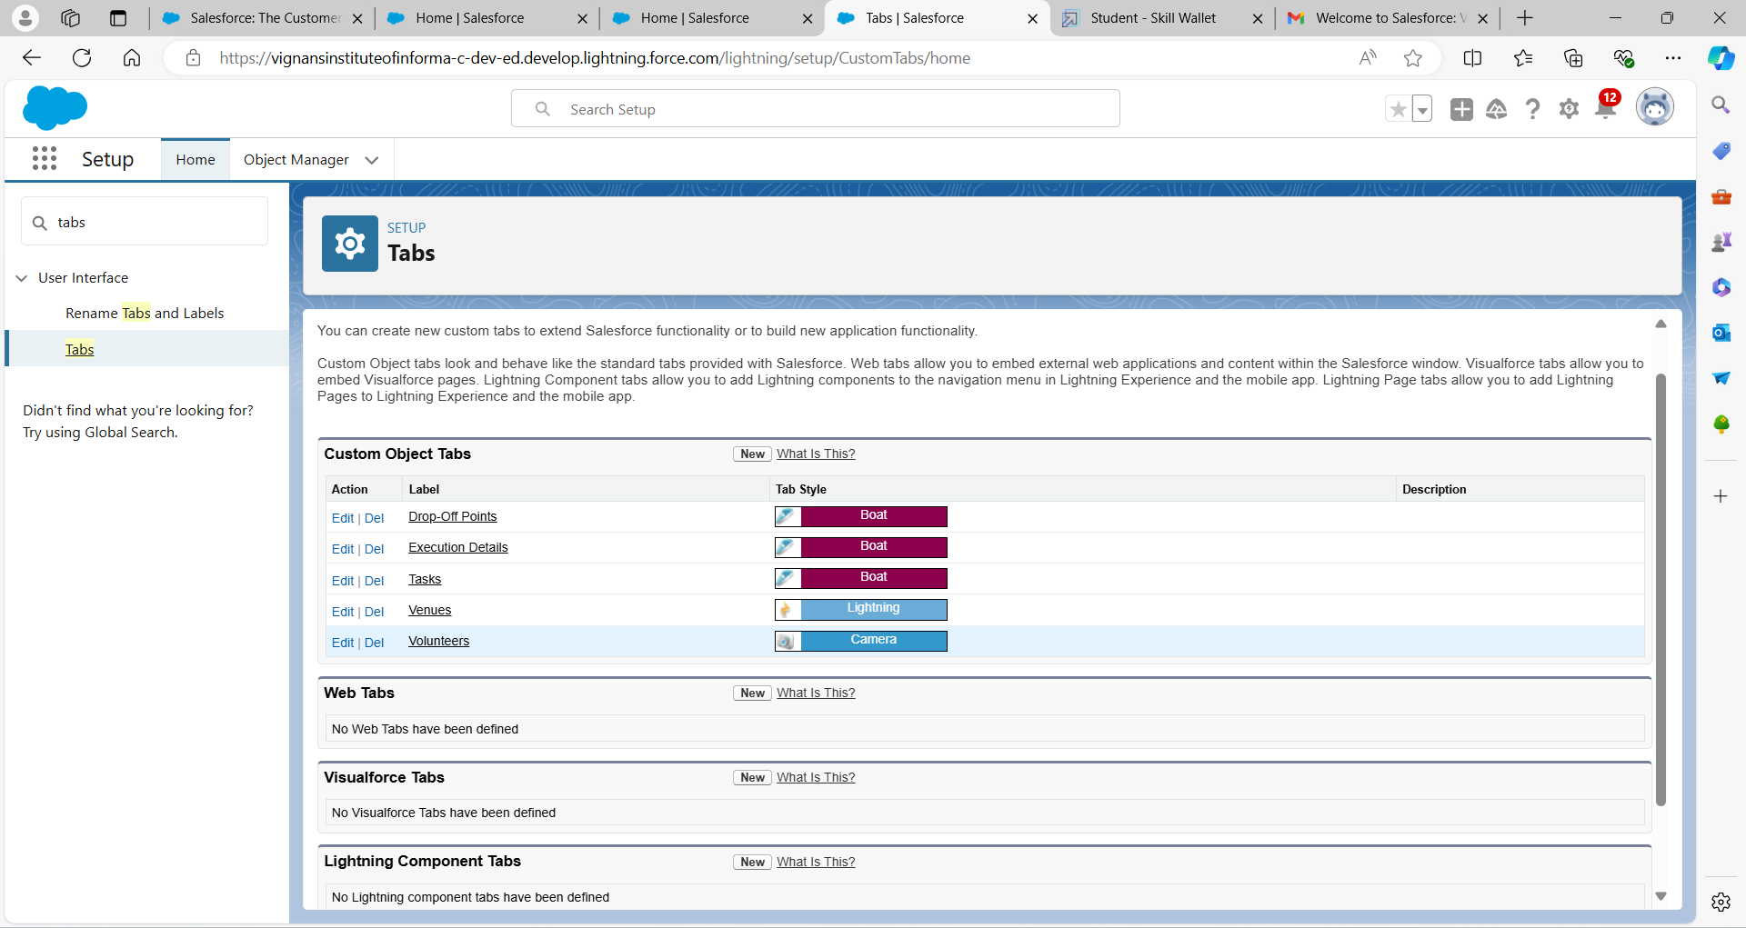

### **Create A Lightning App**

1.Go to setup page >> search “app manager” in quick find >> select “app manager” >> click on New lightning App.

Fill the app name in app details and branding as follow  
2.App Name : FoodConnect  
Developer Name : auto populated  
3.Then click Next  >> Navigation Style as Standard Navigation >> Next.

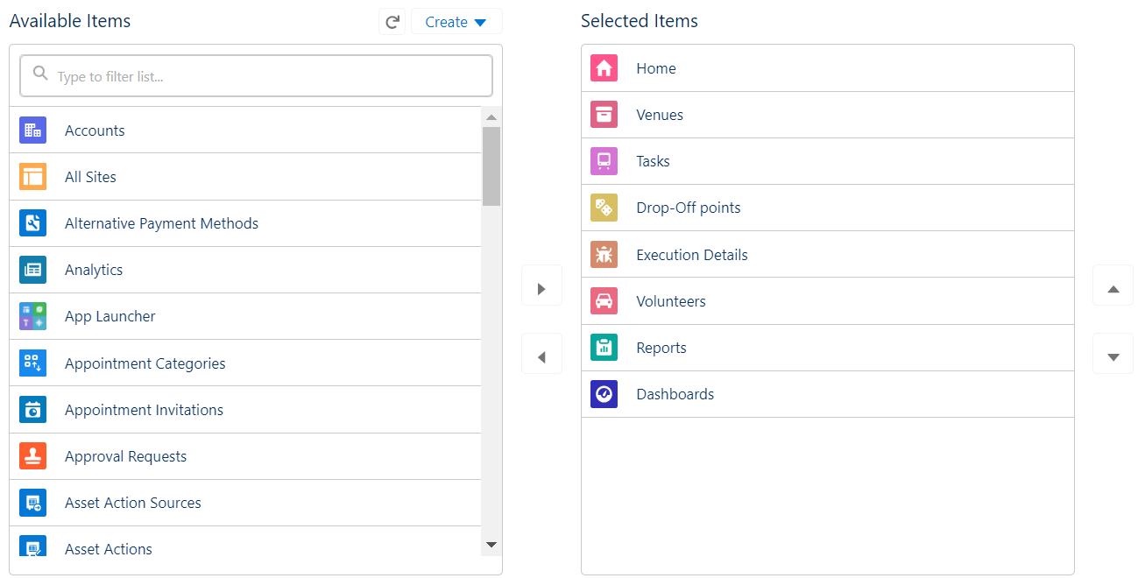Search for the item in the (Home, Venue, Drop-Off Point, Task, Volunteer, Execution Details, Reports) from the search bar and move it using the arrow button >> Next >> Next.

6. To Add User Profiles:

Search profiles (System administrator) in the search bar >> click on the arrow button >> save & finish.

### **Fields:**

**Fields on Venue Object:**

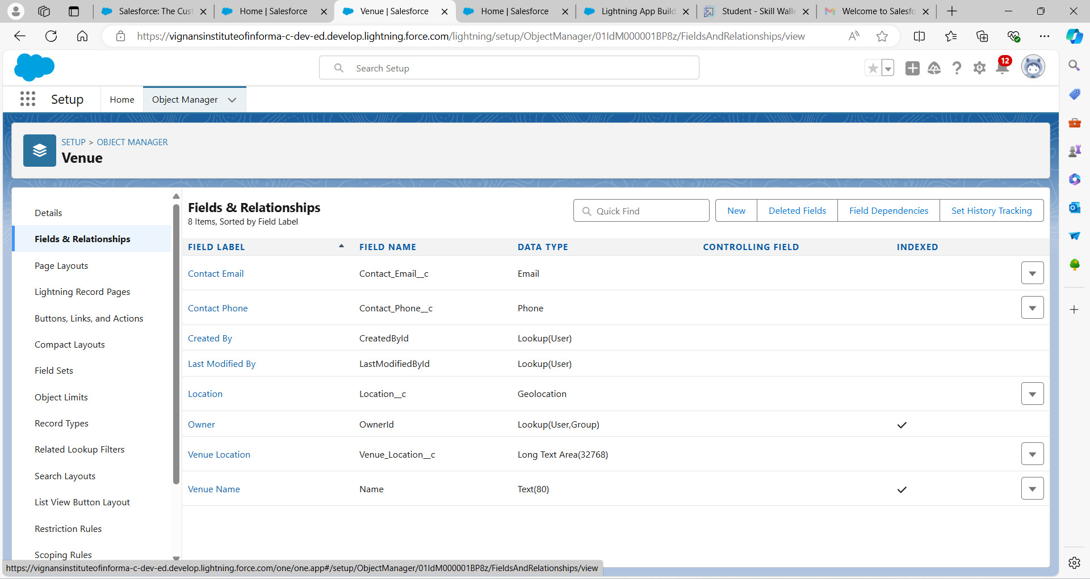

**Fields on Volunteer Object:**

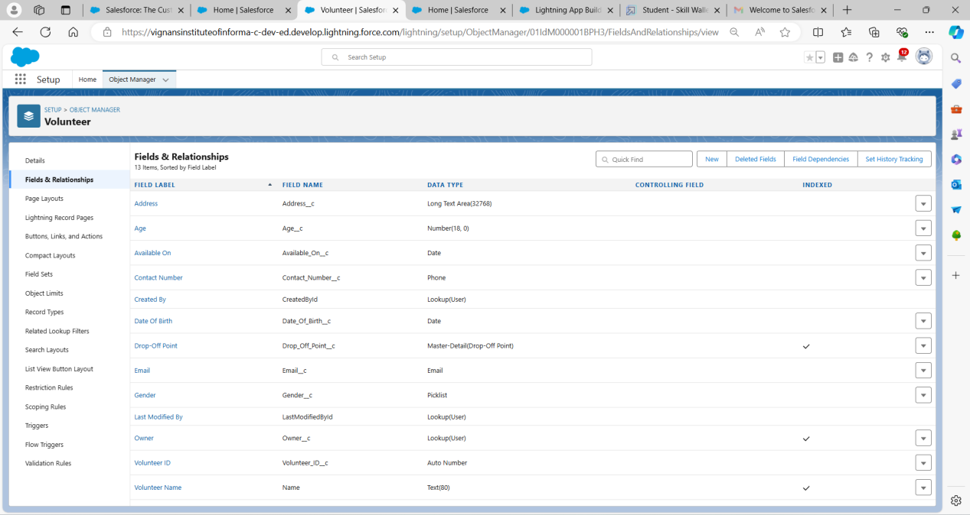

**Fields on Execution Detail Object:**

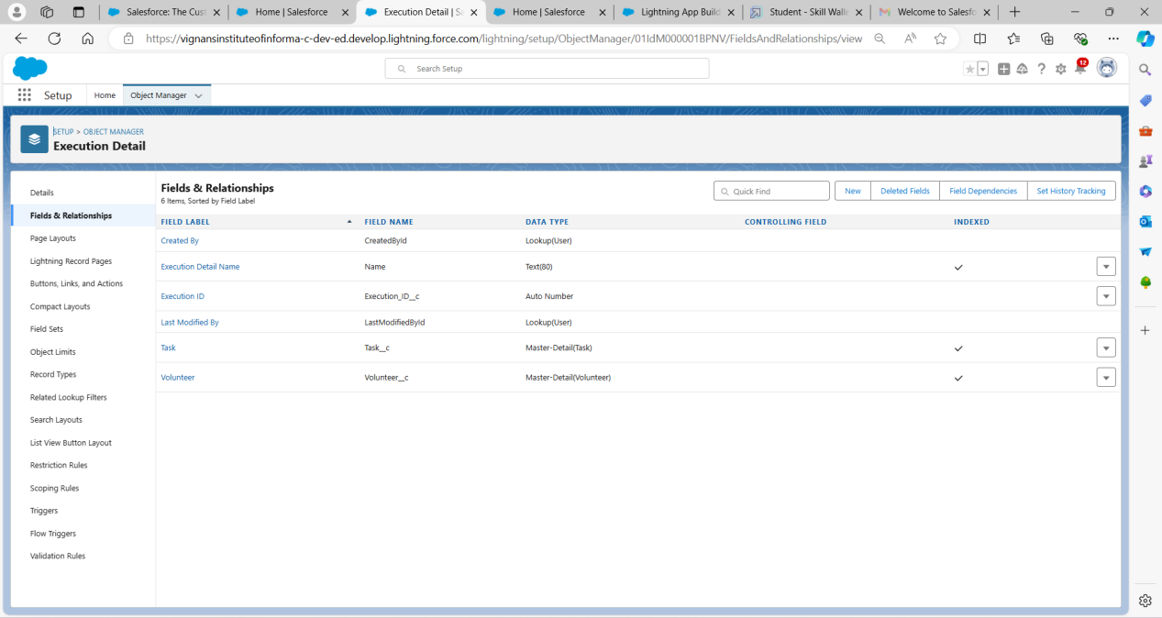

**Fields on Task Object:**

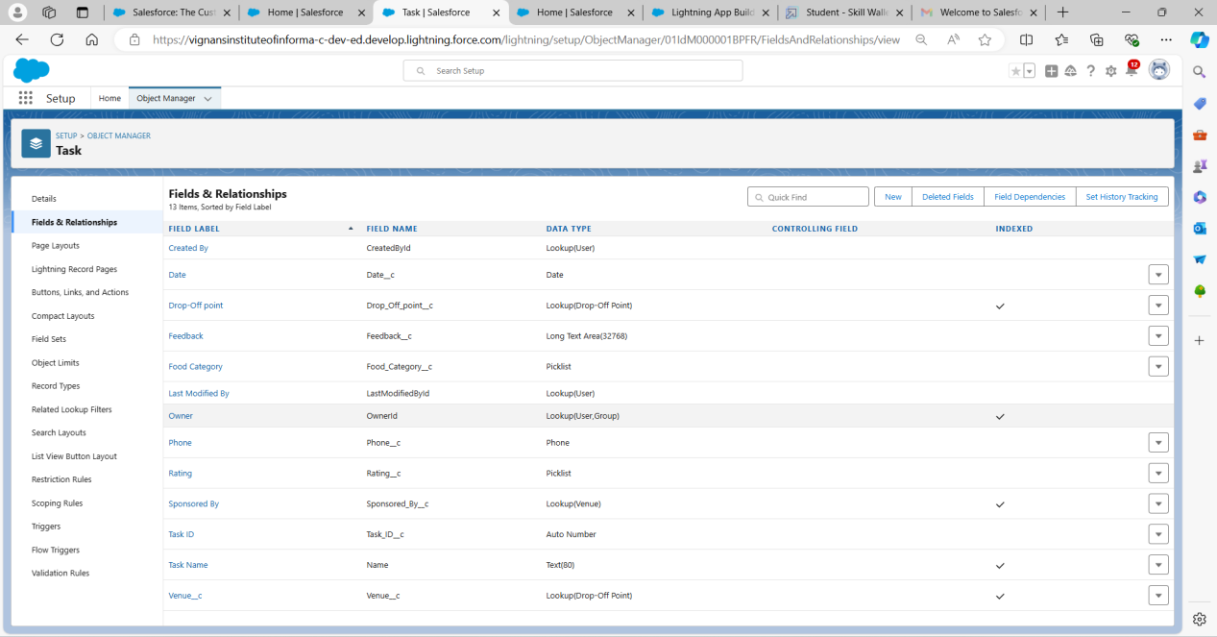

**Fields on Drop Off Point Object:**

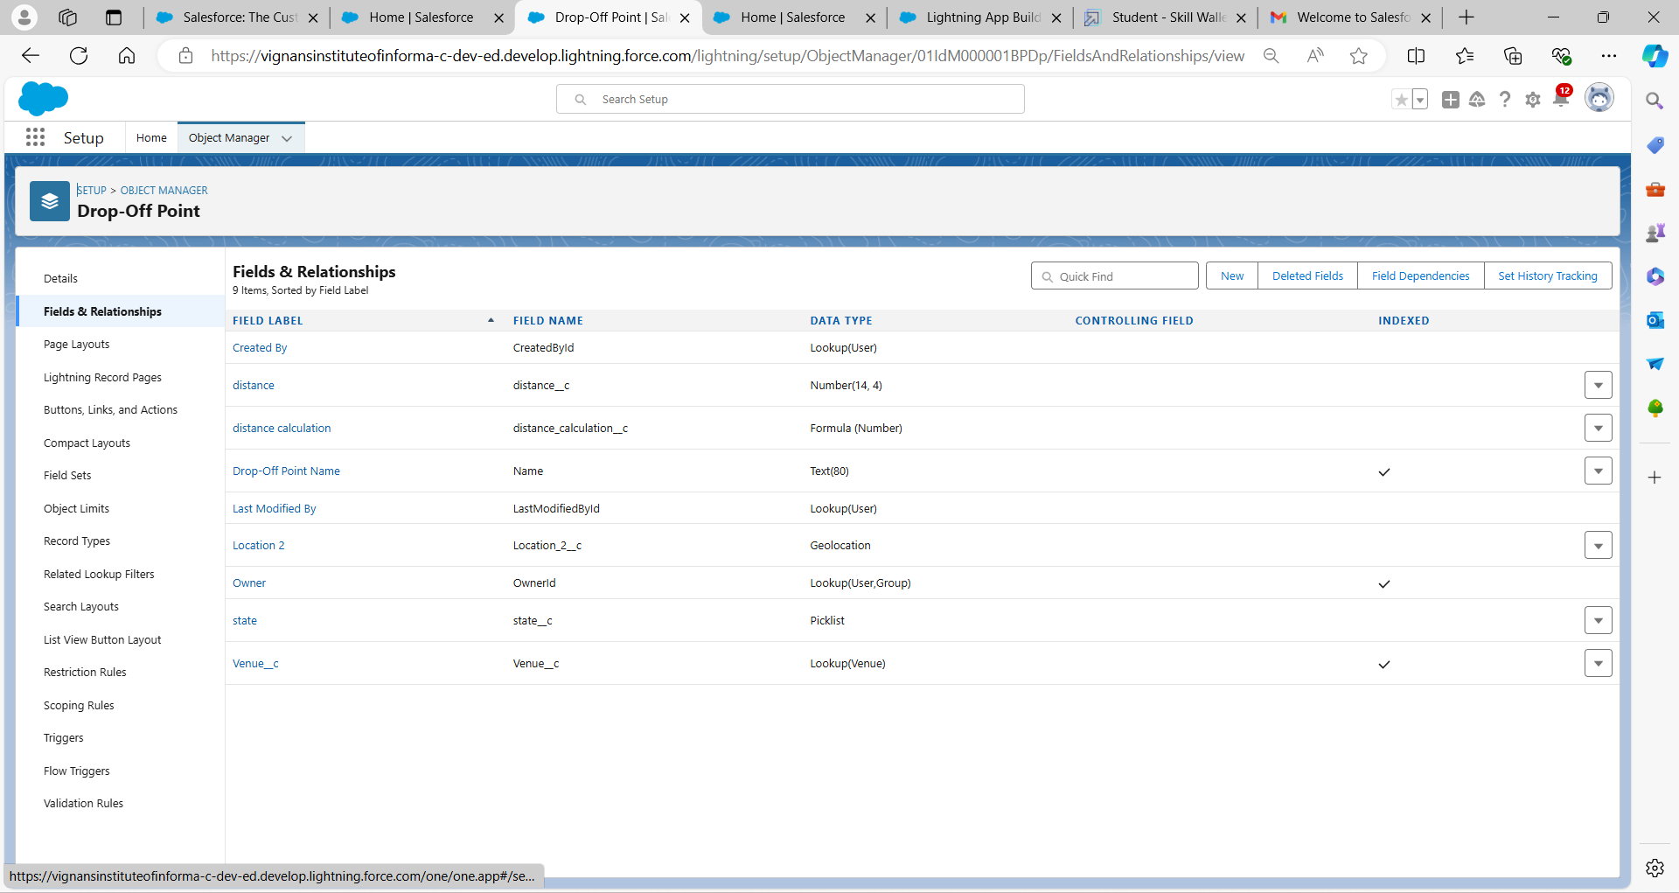

**FLOWS:** To perform some automated actions like sending email alerts or tasks,launching flows,creating,updating,deleting,having visual interface and taking the inputs from them, we need flows

1. Go to setup >> type Flow in quick find box >> Click on the Flow and Select the New Flow.
2. Select the type of flow :Screen flow name it as Label :Venue_detail

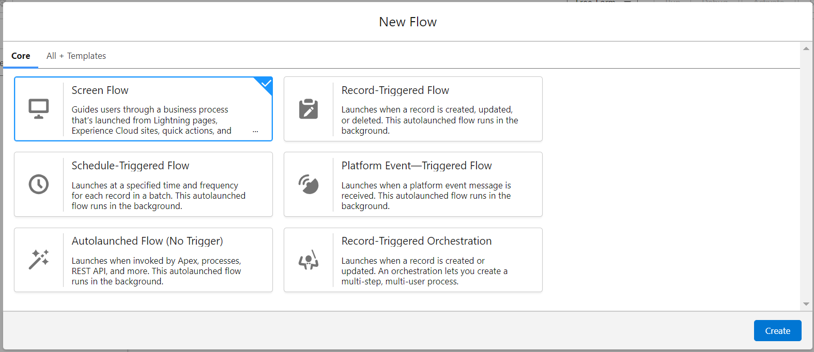

1. Now add components in this flow. Click on Text Component and name
2. Click on Email Component and name it as:Label : Email,API Name : Contact_Email.
3. Click on Phone Component and name it as:Label : Phone,Contact_Phone
4. Create a Text component label it as Venue Location
5. Click on Number Component name it as Latitude
6. Click on Number Component name it as Longitude
7. Click on Create Venue Record:

Label : Create Venue Record

API Name : Create_Venue_Record

How Many Records to Create : One

To Set the Record Fields : Use separate resources, and literal values

Object : Venue

Set Field Values for the Venue : Click on ‘Add Field’ 5 times

Field : Value = Contact_Email__c : {!Contact_Email.value}

Field : Value = Contact_Phone__c : {!Contact_Phone.value}

Field : Value = Name : {!Venue_Name}

Field : Value = Venue_Location__c : {!location}

Field : Value = Location__Latitude__s : {!latitude}

Field : Value = Location__Longitude__s : {!longitude}

10.Click on save

**TRIGGER:**

To perform an action automatically when you do a task(like inserting a record,updating,deleting,creating) .

1. Trigger Name:DropOffTrigger
2. Sobject DropOff Point

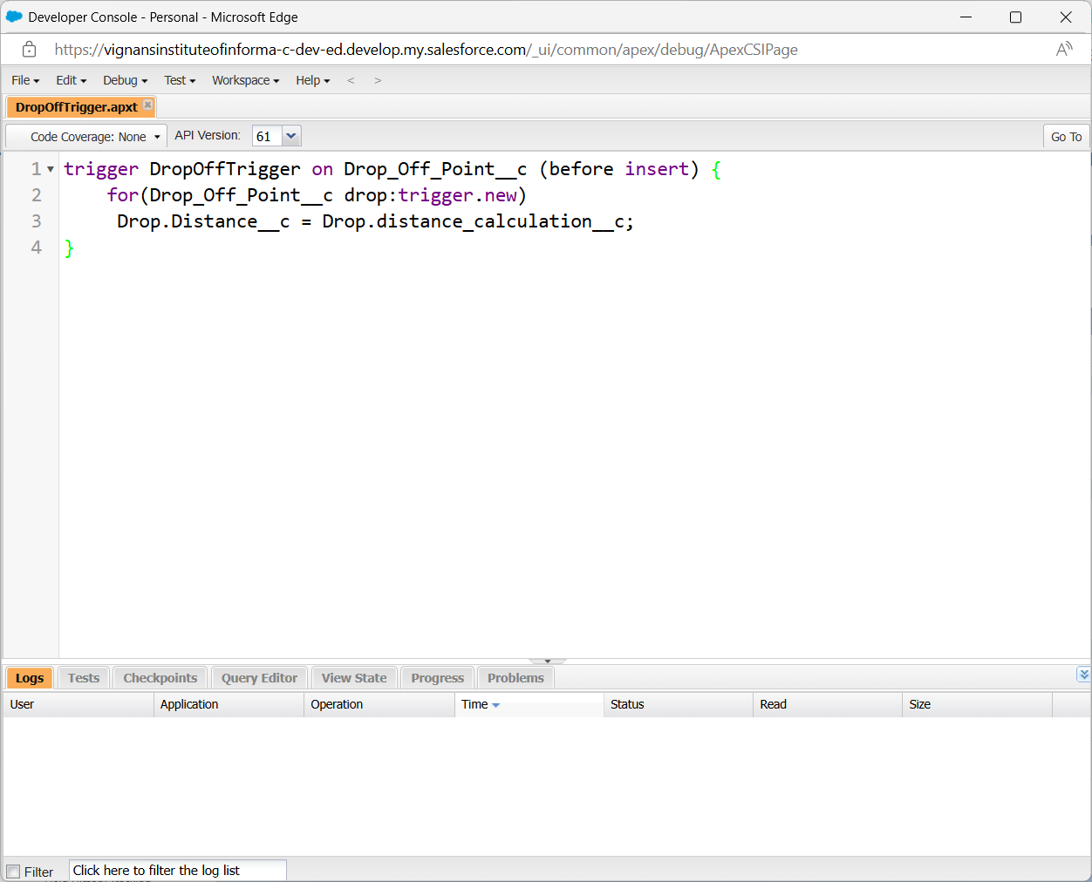

### **Profiles**

Profile handle tabs,fields and recordlevel security, it contains permissions and settings .settings will tell what objects the users can see,permisions will tell what users can do with that object :Create,read,Update,Delete .

1. Create a NGO Profile by cloning standard profile .

We created three users with NGO profile:

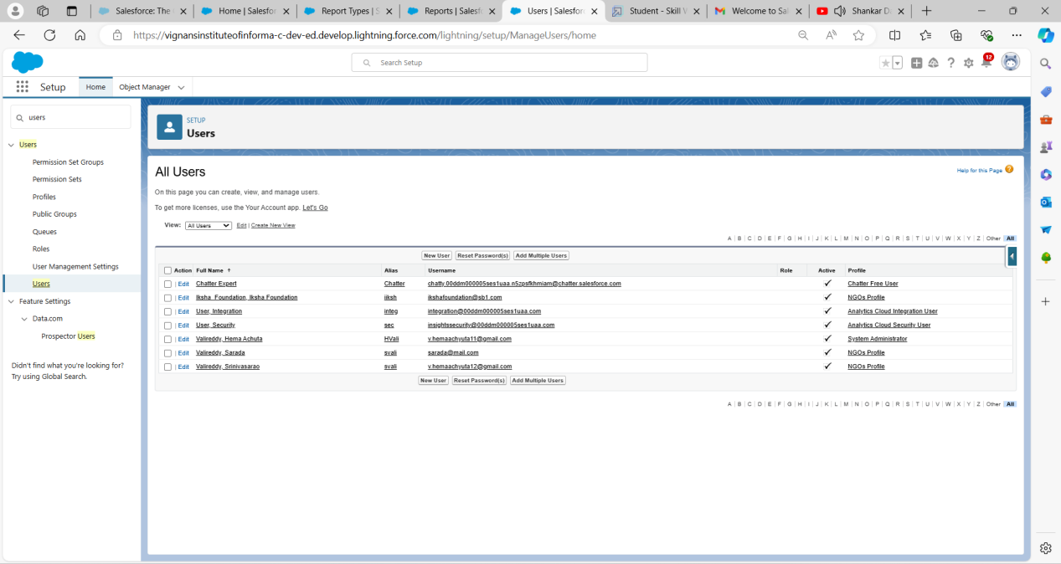

### **Creation Of Public Groups:**

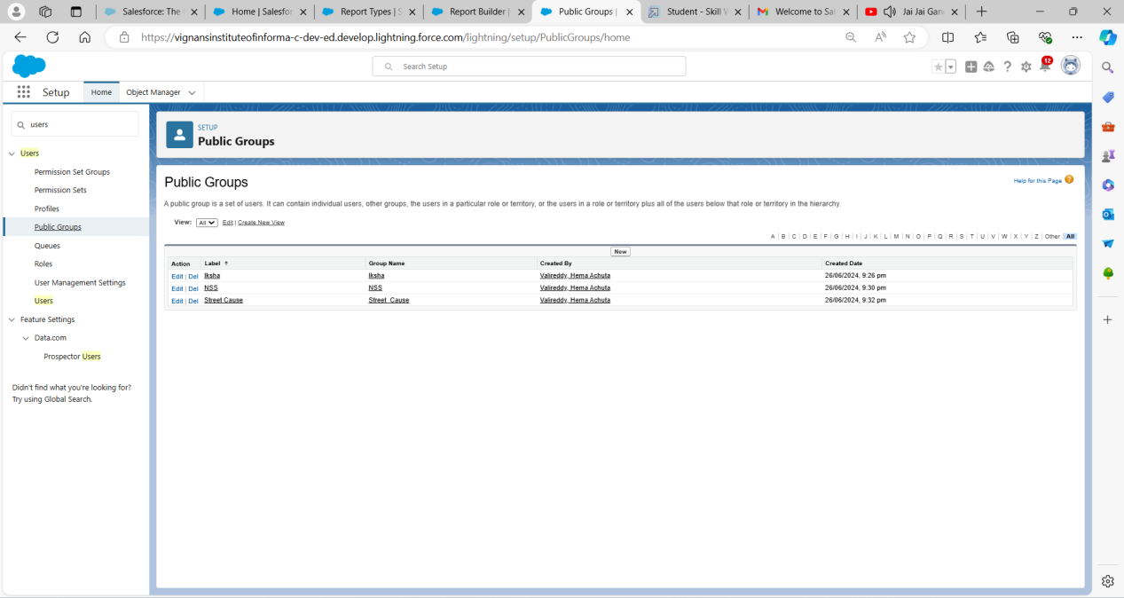

### **Reports &Report Types**

1.In Define the Custom Report Type:

Primary Object : Select Venues

Report Type Label : Venue with DropOff with Volunteer

Report Type Name : Venue_with_DropOff_with_Volunteer

Description : Venue with DropOff with Volunteer

Store in Category : Select Other Reports

Deployment Status : Deployed.

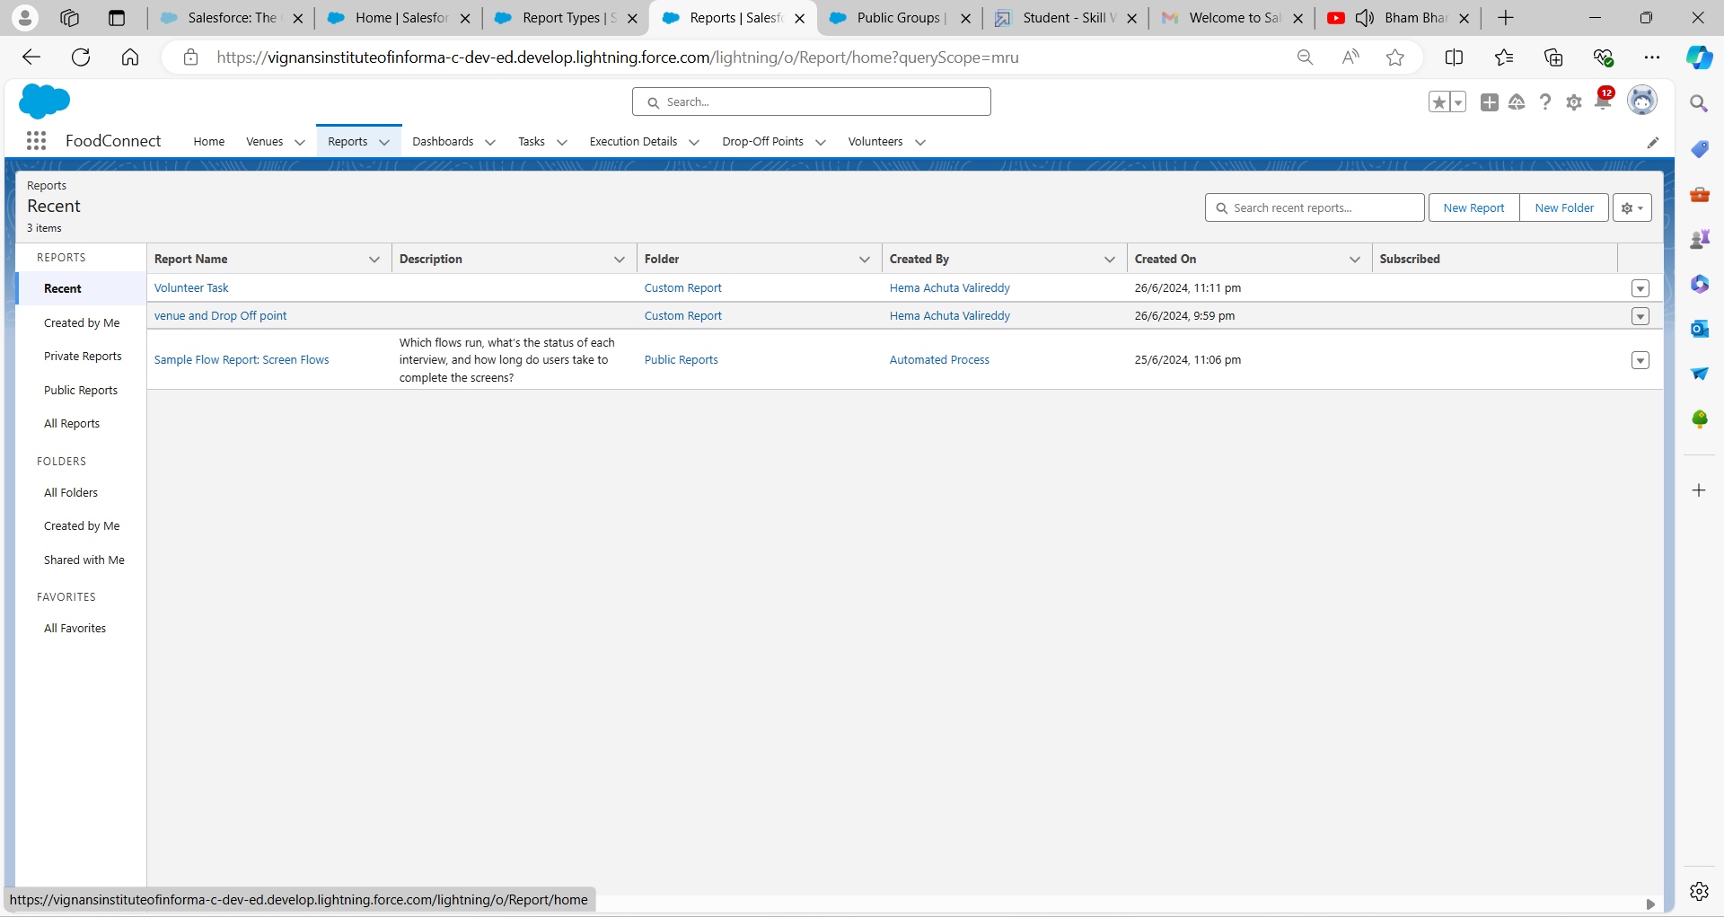

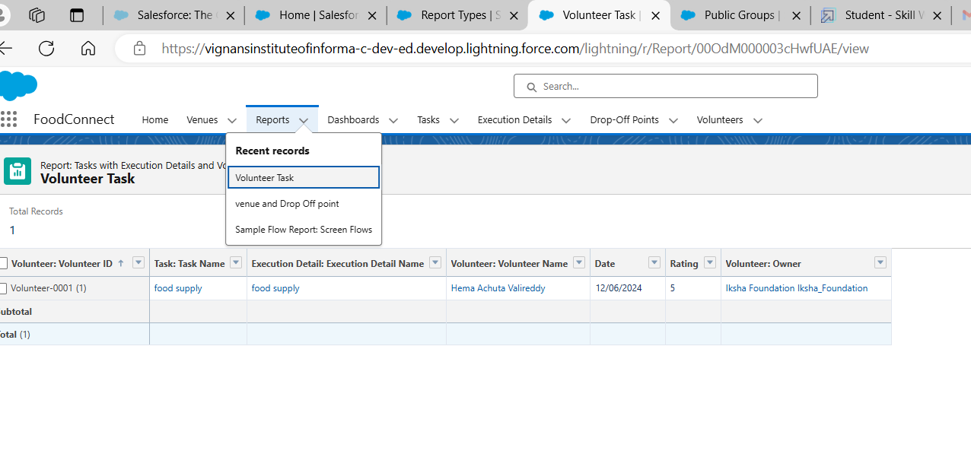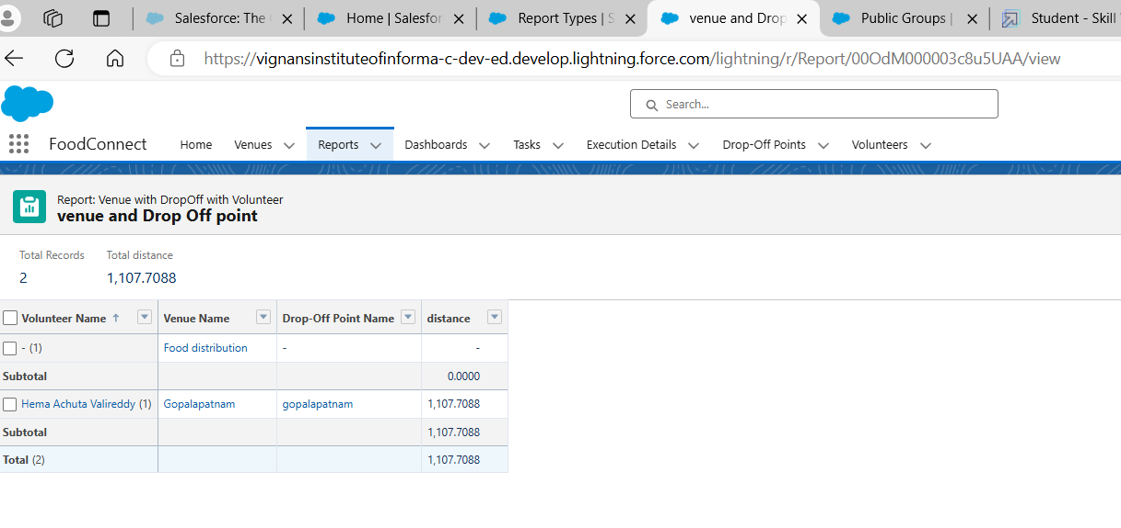

**Dashboard:**

[Dashboards are interactive collections of widgets that show query results from your data](https://www.bing.com/ck/a?!&&p=67d25b1deb698decJmltdHM9MTcxOTQ0NjQwMCZpZ3VpZD0zODZmYzlmYy1jNDk2LTYwZDEtMDUwZi1kYTIzYzUzMDYxZmYmaW5zaWQ9NTkyOA&ptn=3&ver=2&hsh=3&fclid=386fc9fc-c496-60d1-050f-da23c53061ff&psq=dashboard+in+salesforce&u=a1aHR0cHM6Ly90cmFpbGhlYWQuc2FsZXNmb3JjZS5jb20vY29udGVudC9sZWFybi9tb2R1bGVzL3dhdmVfZXhwbG9yYXRpb25fZGFzaGJvYXJkX25hdmlnYXRpb24vd2F2ZV93b3JrX3RoZV9kYXNoYm9hcmQ&ntb=1" \t "https://www.bing.com/_blank).

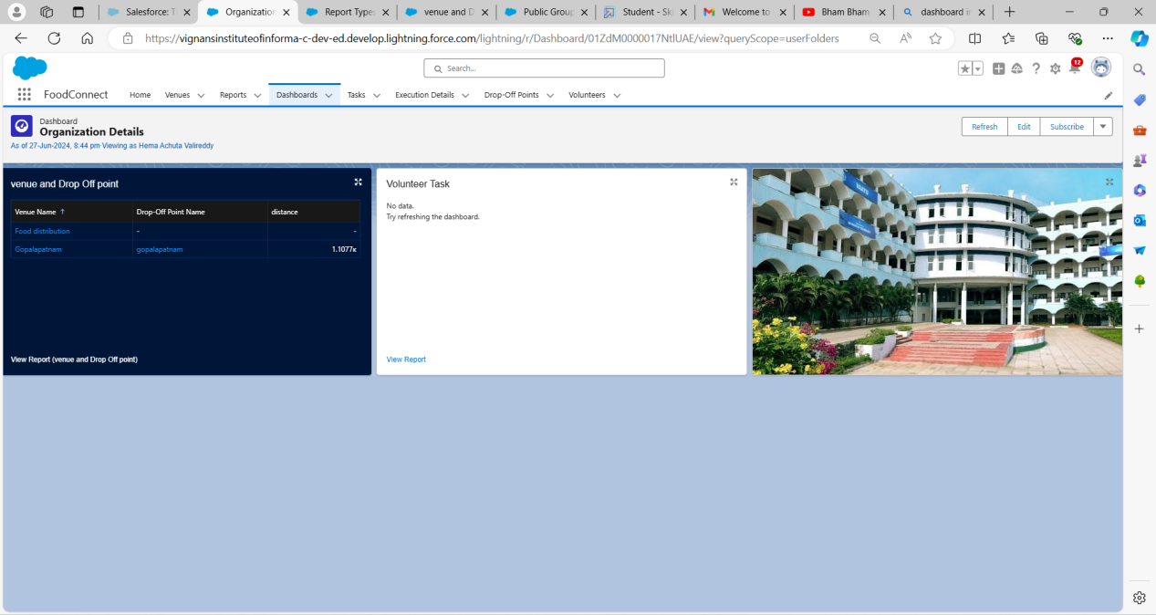

**Sharing Rules:**

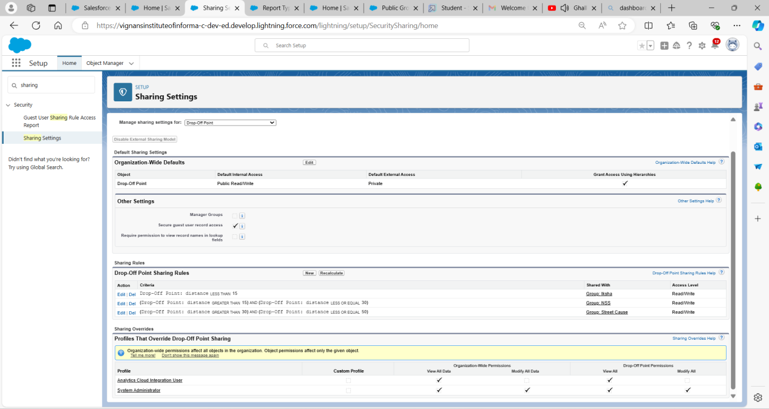

**HOMEPage:**